**Introduction:**

Prometheus is a monitoring tool. It is used for infrastructure monitoring (known as metrics check) – like, CPU utilization, Ram utilization, disk. In AWS does this monitoring using Cloud watch, but using cloud watch we can monitor only 17+ metrics, whereas in Prometheus, we can perform more than 100+ metrics. Prometheus works on Times series Database.

We should have a dedicated instance for Prometheus. Prometheus uses pull mechanism. Node explorer collects all data and store it in a single place, and Prometheus checks the data from this node explorer and creates dashboard.

**Process:**

1. Create 2 instances, one for Prometheus (Master machine) & other for node explorer.
2. Prometheus is an open source and can be downloaded from “Prometheus.io” 🡪 Download 🡪 Prometheus🡪 get the tar file download path

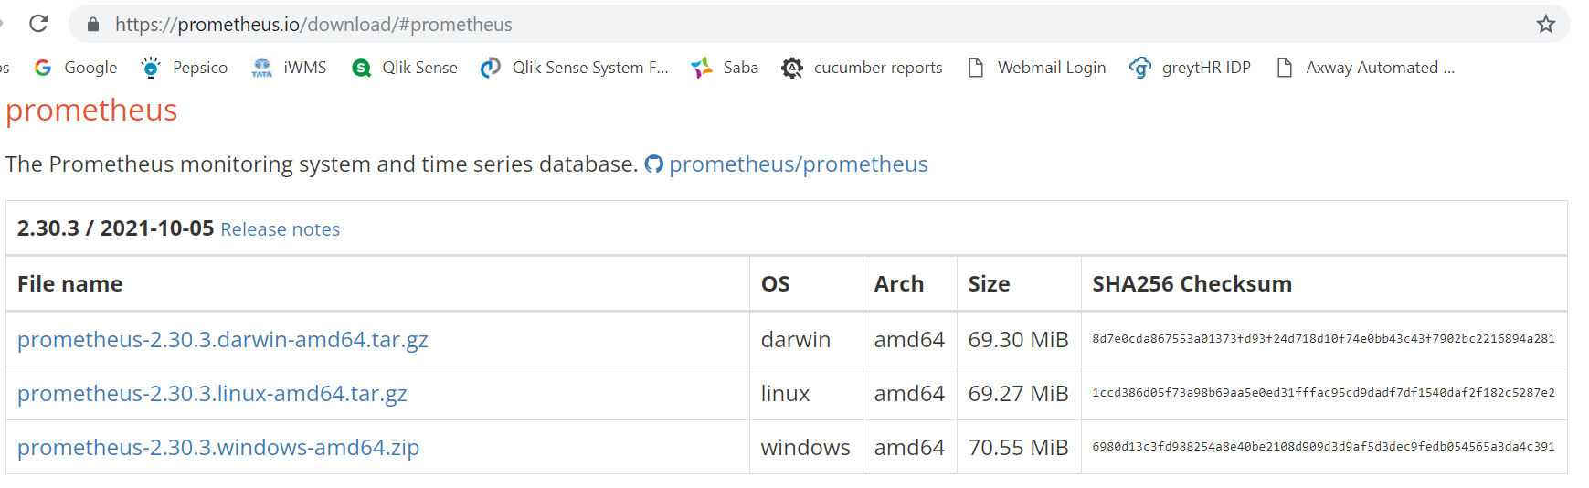

1. download the tar file using wget command in linux master
2. now to untar the file, use “tar -xvzf <tar file name with extension>” command

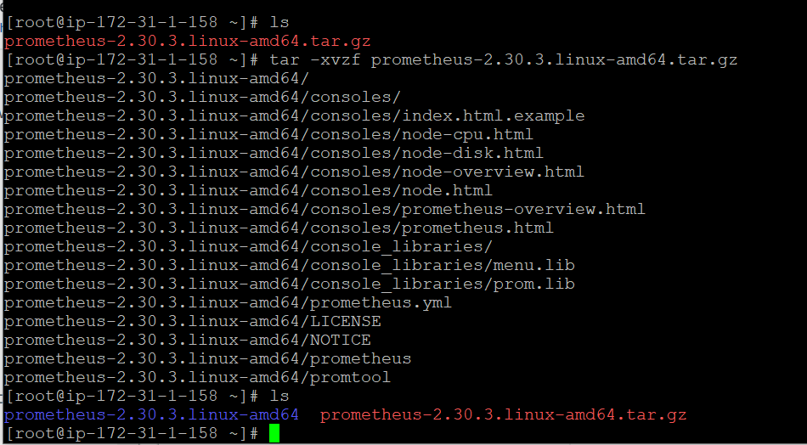

1. if you move to Prometheus folder, you can view Prometheus executable file, yaml file. yaml file has minimum 15 sec, for which Prometheus checks the node executor. Yaml is the config file.

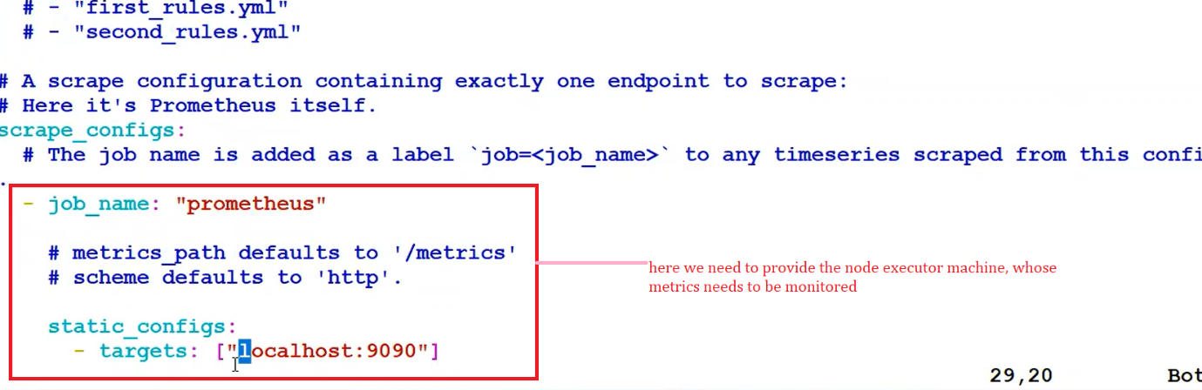

1. in linux machine, executable files should be kept in /usr/local/bin folder, so that it can be executed from anywhere. So, copy the executable Prometheus file to /usr/local/bin using cp <Prometheus executable file name> /usr/local/bin
2. ./Prometheus --config.file=Prometheus.yml , use this command to start the executable file. Yaml file is the heart for this. This command is executing in front end, if you hit ctrl+c, then the processor will end. to make this run at backend, “./Prometheus --config.file=Prometheus.yml &”

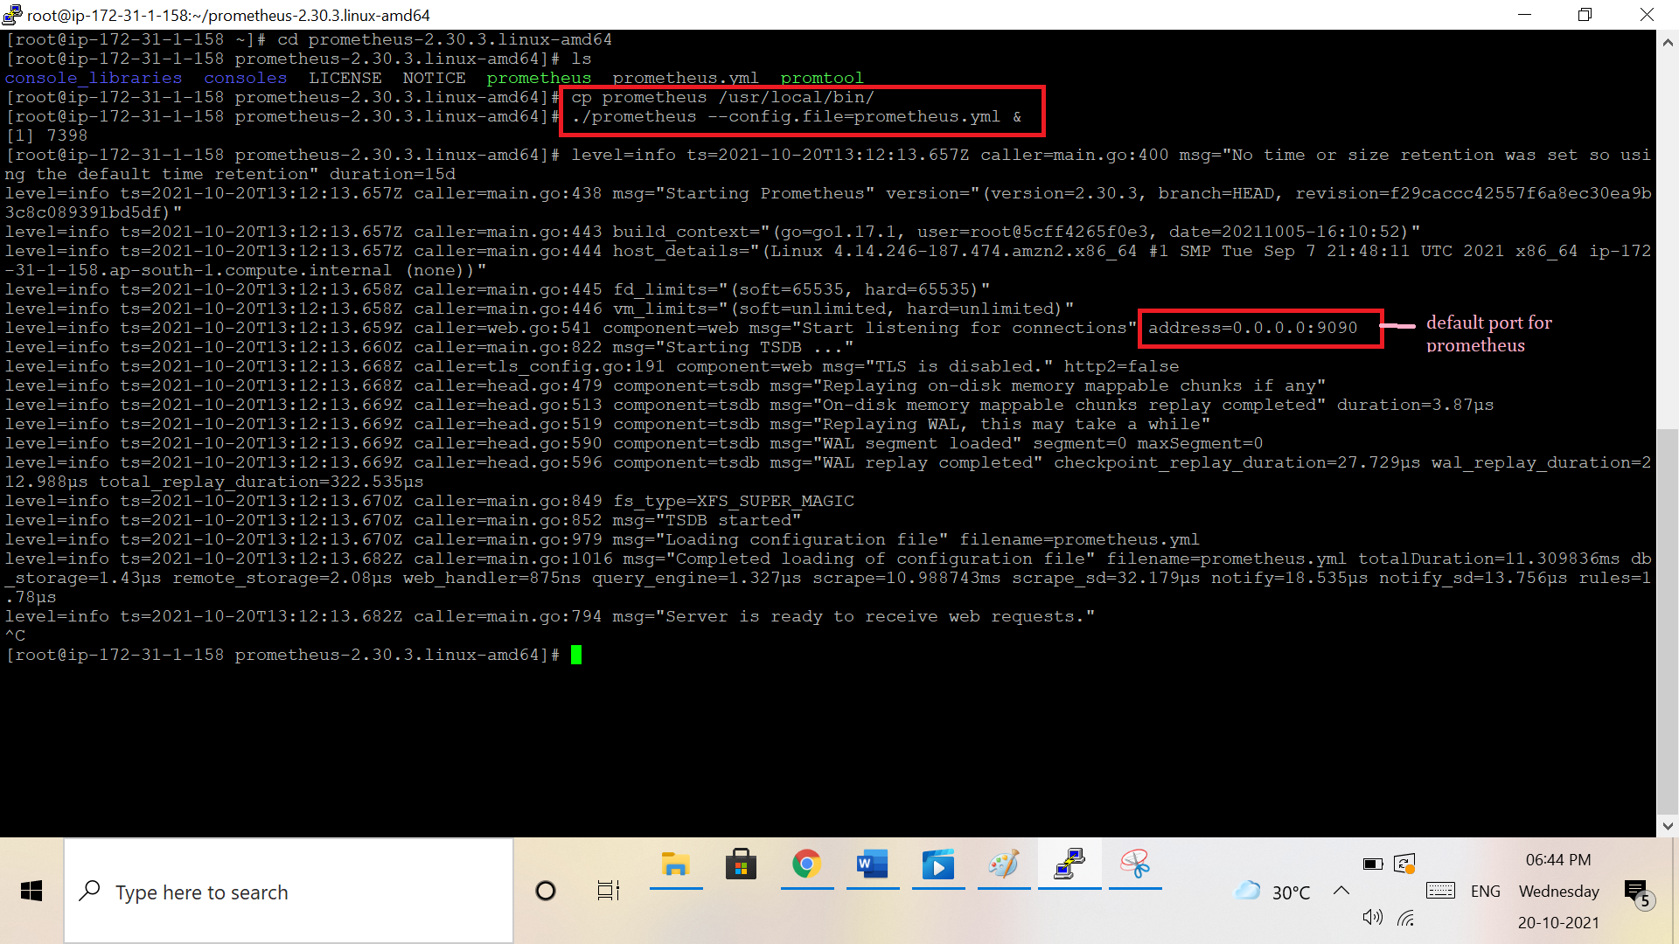

1. the port number for Prometheus is “9090”, you can view graphs of master machine by choosing the metrics & timing. In the above screenshot, in yaml file we have target as “local host” which is the master machine, where Prometheus is installed. Now to add other machines, to view the metrics, we need to add the IP address of new instance into the yaml file.

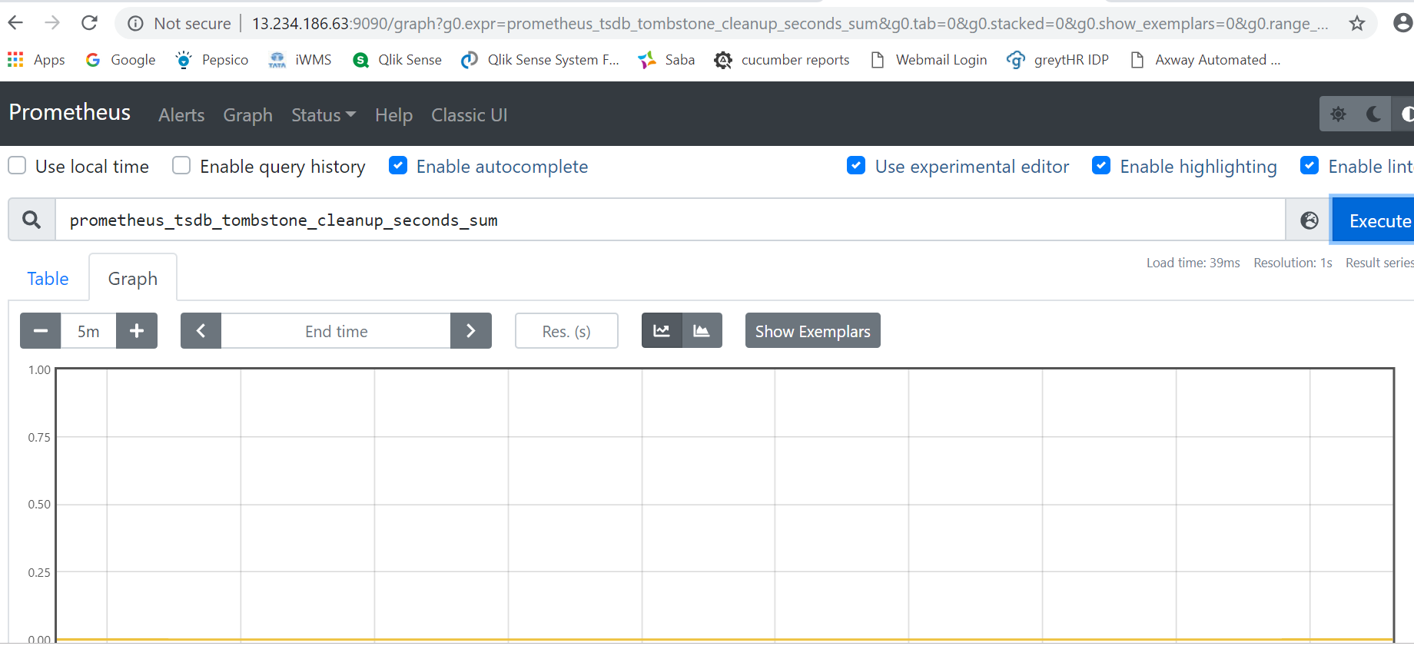

1. To do this, we need to create an instance & download the node explorer (get the link from “Prometheus.io” 🡪 Download 🡪 node explorer🡪 get the tar file download path)

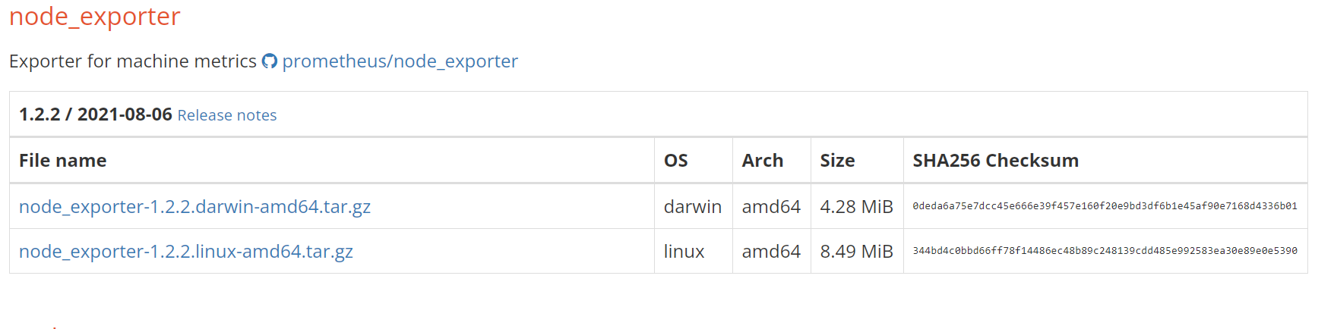

1. move the executable file to /usr/local/bin/ and start the process using “./node_exporter &”

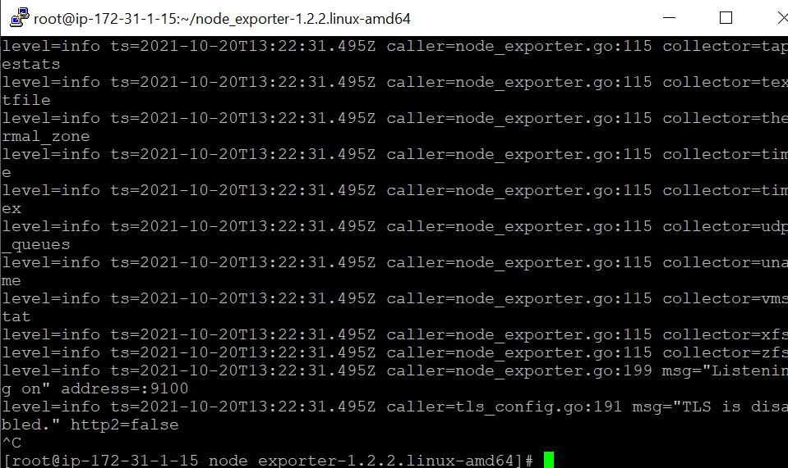

1. after starting the process you get the port number “9100” which is for node exporter

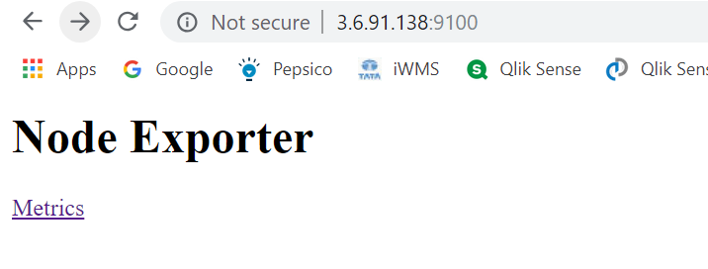

1. now to get the information of node explorer connected machines, from master machine, we need to add the IP address of the node explorer installed machines in the master’s yaml file as mentioned above:

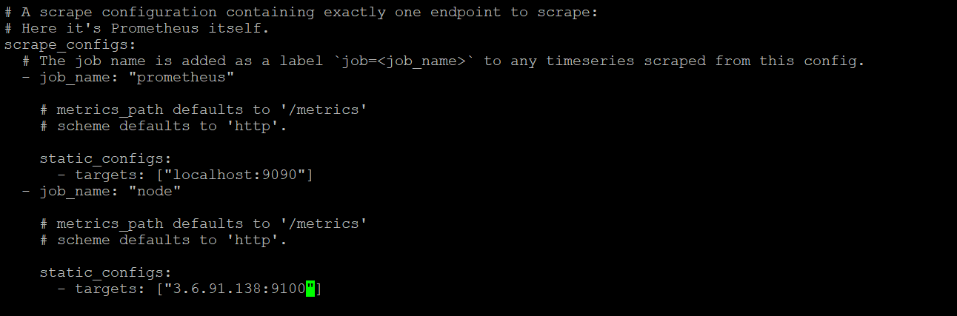

1. as we have changed the config file, service needs to be restarted by killing the process ID. TO view the process ID, “ps -ef | grep Prometheus” command
2. “kill -9 <process ID>” command is used to kill the process using process ID

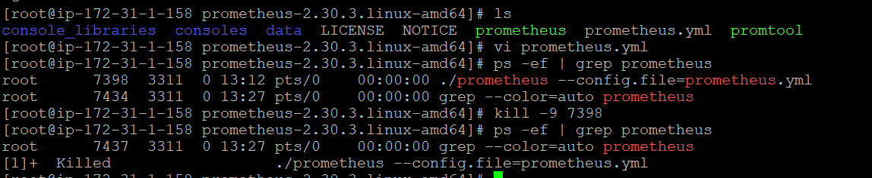

1. now again start the prometheus service using above command
2. You can view the metrics for both master & node explorer in Prometheus browser.

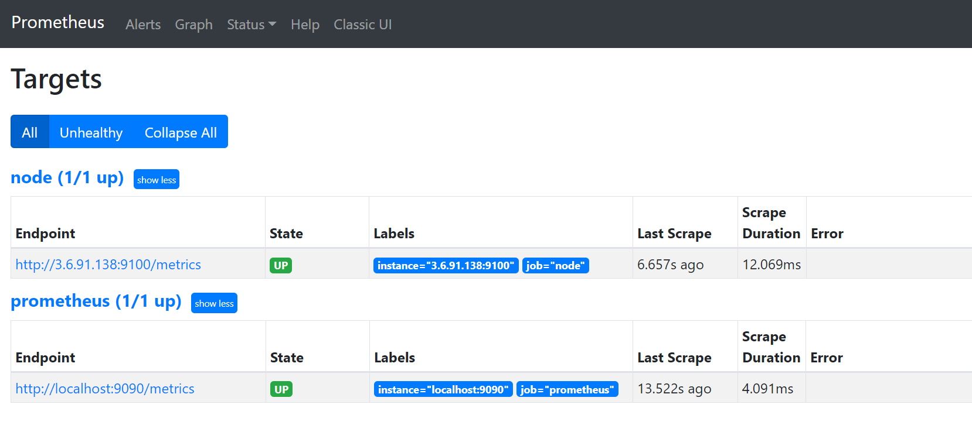

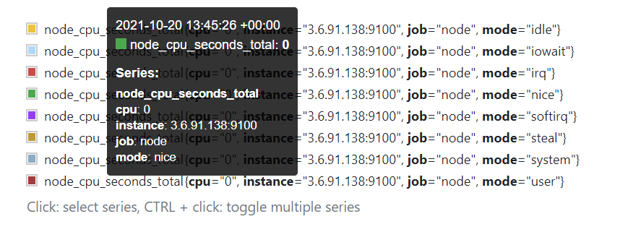

**Grafana:**

It is a visualization tool. It provides visualization for many tools like cloud watch, splunk, Prometheus. Grafana has both open source & enterprise versions. Grafana can be download from “Grafana.com”. Grafana 🡪 open source 🡪 download

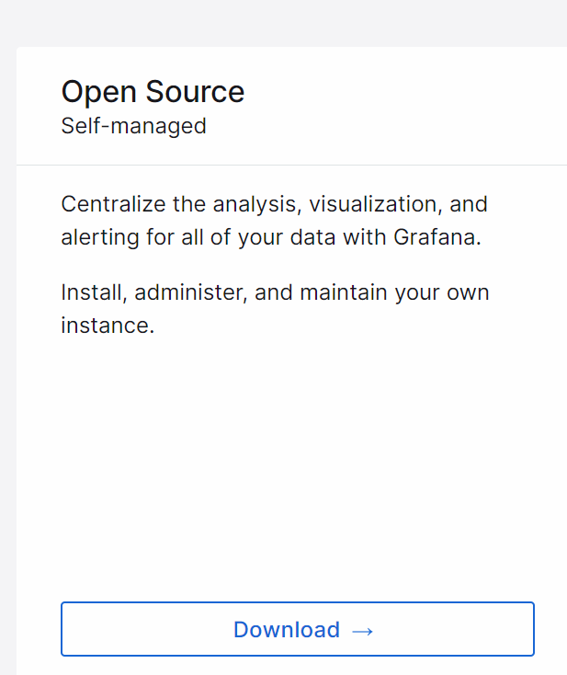

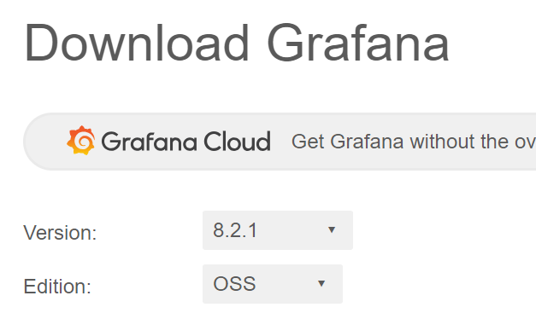

Grafana can be downloaded to master machine, where Prometheus is installed.

**Process:**

1. download the tar file in master machine and untar it
2. navigate to Grafana folder, then to bin, where you can find “Grafana.server”
3. need to execute the “Grafana.server” file using “./grafana.server &”
4. you get port number as 3000
5. 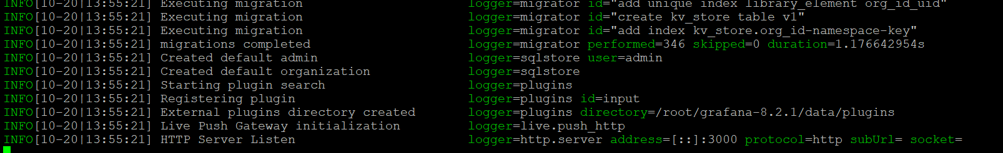
6. Grafana can be accessible using <master ip address>:3000
7. you can set the username & password as you wish
8. once logged in, you can add data source (Prometheus, cloud watch, Splunk, etc)& create dashboard.
9. provide the URL as “<master ip address>:9090” and save
10. now Prometheus will be added
11. either you can use the default dashboards provided by Grafana or you can create a new dashboard as you wish
12. you can import the default dashboard by clicking the import button & providing the ID:

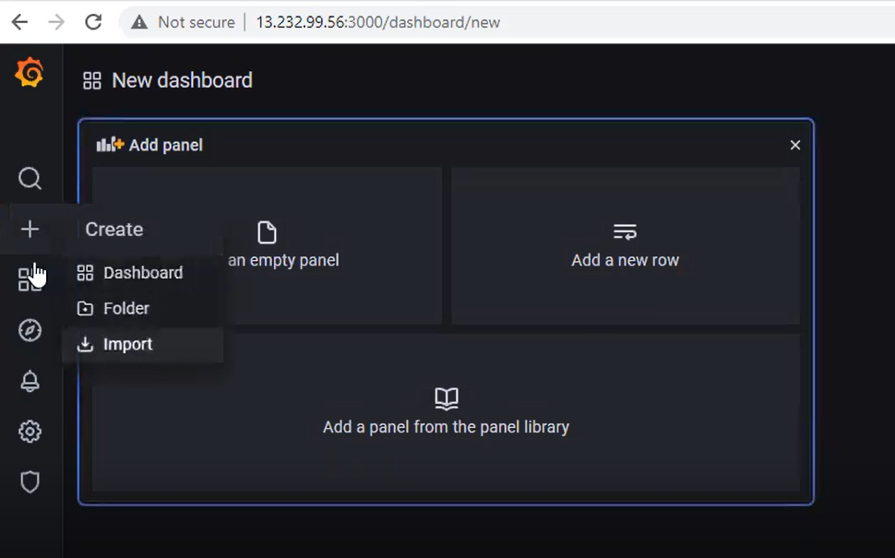

1. click load & then import
2. you can view the node explorer machine’s metrics details.